

**Excel Assignment - 18**

1. What are comments and what is the importance if commenting in any code?

Answer: A VBA COMMENT is a green line of text that helps you to describe the written code. In simple words, a comment is a line of text which is not a code and VBA ignores it while executing the code. Importance of comment:

* Helps you to Document your Work: You can use a comment to describe how code works, which can help you in the future to recall it easily or any other user.
* Track the Changes: If some codes need you to change them frequently you can use comments to track or record changes within the code.
* Describe a Function Procedure: When you write a procedure you can add a comment at the starting to describe the purpose of this procedure and how it works.
* Describe a Variable: Variables are one of the most important things that you need to use while writing a VBA code and you can use a comment to describe a variable.
* Debug Your Code: You can use VBA comments to debug the code by converting code lines into comments for testing.

1. What is Call Statement and when do you use this statement?

Answer: The CALL statement transfers control from one object program to another within the run unit. The program containing the CALL statement is the calling program, the program identified in the CALL statement is the called subprogram.The CALL statement is for use only with stored procedures that return voids. This statement cannot be combined with other functions or operators within an MDX expression.

1. How do you compile a code in VBA? What are some of the problem that you might face when you don’t compile a code?

Answer: Steps to compile a code in VBA:

Step1 - open excel

Step2 - right click on the sheet tab

Step3 - view source code

Step4 - write a sub in vb editor

Step5 - debug / compile vba project

* Syntax errors – A specific line of code is not written correctly
* Compile errors – Issues that happen when putting together lines of code, though the individual lines of code seem to make sense
* Runtime errors – When the code is usually correct in principle, but an action taken by the user or the data being used leads to unexpected errors.

1. What are hot keys in VBA? How can you create your own hot keys?

Answer: A hot key is a key or a combination of keys on a computer keyboard that, when pressed at one time, performs a task (such as starting an application) more quickly than by using a mouse or other input device. Hot keys are sometimes called shortcut keys. Hot keys are supported by many [operating system](https://www.techtarget.com/whatis/definition/operating-system-OS) and applications.To create hot keys these are steps:

1. From the Tools menu, select Macro, and then Record New Macro.  
2. In the Macro name box, insert a name for the macro (no spaces are allowed between characters).  
3. In the Shortcut key box, press Shift+ V.  
4. Choose Personal Macro Workbook from the Store macro in dropdown list, and click OK.  
5. Record anything you like and then stop recording by pressing the Stop Recording icon.  
6. Open the VBE (Visual Basic Editor) by pressing Alt+F11.  
7. Double-click Module1 under VBA Project (PERSONAL.XLS).  
8. In the Paste Values macro, replace the lines recorded with:  
Selection.Formula = Selection.Value  
This code converts a selected cell's formula to its current value.  
9. Click Save.  
10. Press Alt+F4 to close and then reopen Excel.  
11. To determine if PERSONAL.XLS is open, select Unhide from the Windows menu.  
12. To check the keyboard shortcut, select cells containing formulas, and press Ctrl+Shift+V.

1. Create a macro and shortcut key to find the square root of the following numbers 665, 89, 72, 86, 48, 32, 569, 7521

Answer: 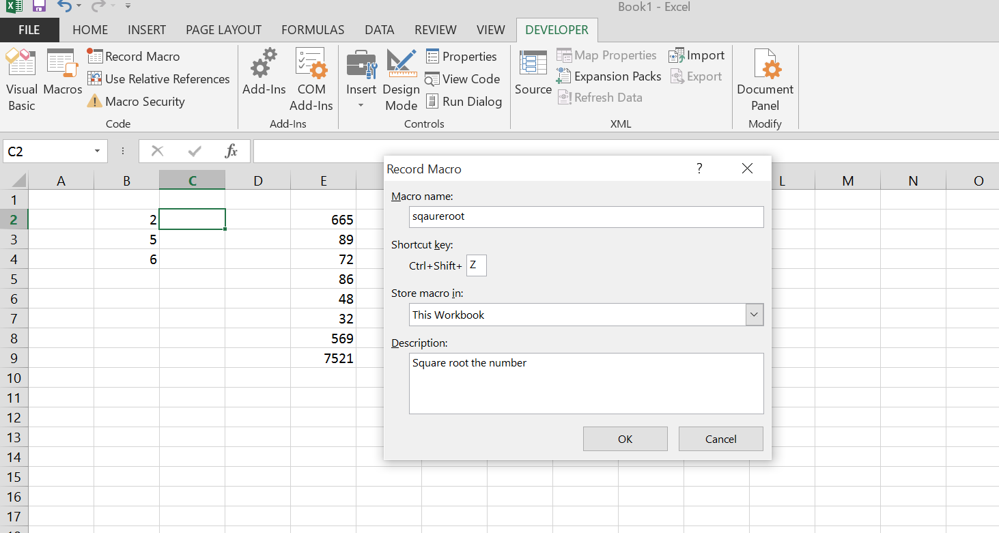

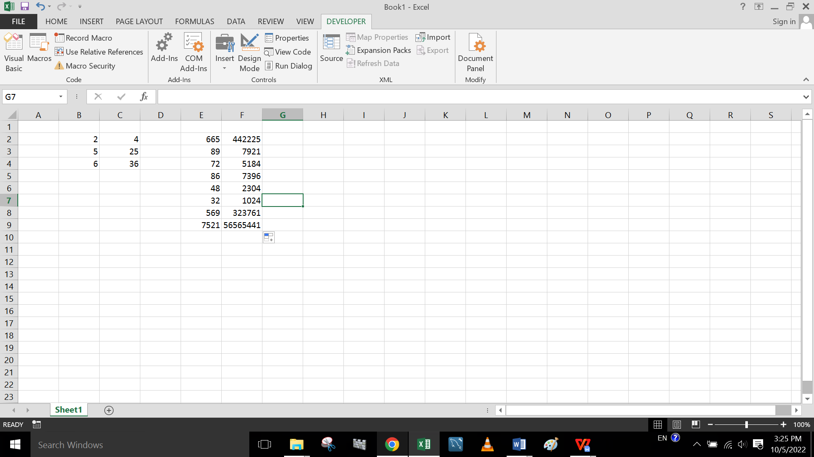

1. What are the shortcut keys used for

* Run the code: Press F8 to run each code line separately.
* Step into the code: F8, Executes the current line and moves to the next line.
* Step out of code: Ctrl + Shift + F, Step Out. Executes the rest of the current procedure.
* Reset the code: F5